5G is about to change the world in ways we can't even imagine yet

- 5G networks were rolled out in 2019 and will expand rapidly in 2020.
- 5G will connect everything and everyone.
- 5G will underpin remote surgery, self-driving cars - and movies you can download in seconds.
We live in a time when words meant to represent significant or unique ideas are so overused they have been trivialized. “Revolutionary” is such a word, a victim of hyperbolic marketing that has rendered meaningless a term meant to evoke profound change to our world. When everything is “revolutionary,” nothing is.
Yet here I am, unable to find an alternative as comprehensively descriptive of 5G and the infinite number of ways the newest generation of wireless technology will change our world. In fact, the revolution has already begun. The global deployment of 5G networks got a running start in 2019 and is set to rapidly expand beyond anything we expected a year ago. But the public understanding of 5G hasn’t caught up.
While 3G put the mobile Internet in your hand and 4G gave us mobile broadband – redefining how we interact with our world – 5G will connect everything and everyone. The technologies within 5G were and continue to be designed to vastly expand network capacity so cars, utility grids, appliances, medical devices, industrial machinery, homes, cities, farms and more can all be connected. And 5G will reduce delays and improve reliability, thereby enabling mission-critical tasks such as remote surgery, self-driving cars and enhanced public safety, to make possible secure connections so lightning-fast that an entire movie can be downloaded in seconds.
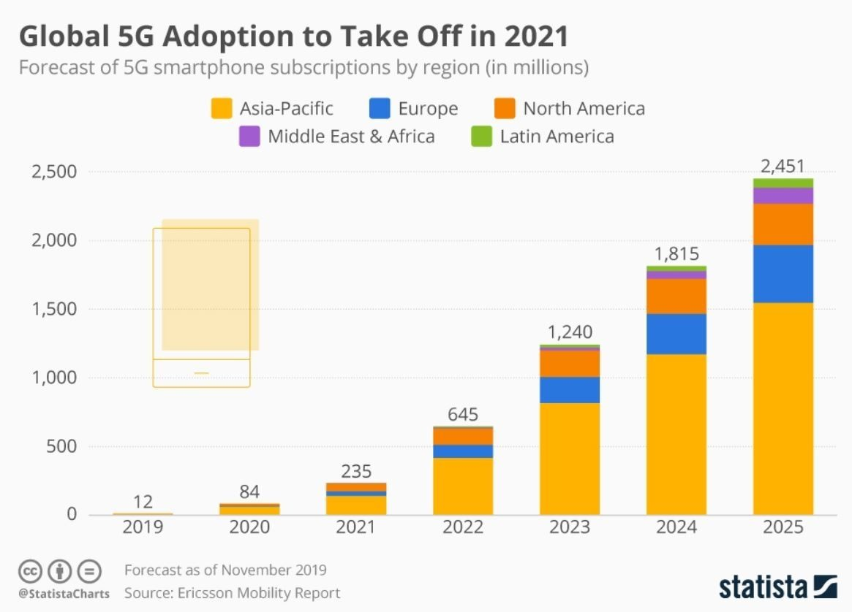
5G adoption will increase rapidly in the coming years
The faster smartphones and always-connected personal computers that consumers are already using on the initial 5G networks are just a hint of the transformations to come. While 3G and 4G technology were designed to put the world in our hands, 5G was and continues to be designed to take the hand out of the equation. The industries and areas of daily life already starting to be changed by 5G include:
- Private networks for factories and industrial facilities: This includes the 5G-enabled Internet of Things with many devices, sensors, applications and mobile connectivity all aimed at improving product quality, increasing productivity, lowering costs and enhancing safety in industrial workplaces. This new connectivity will include factories and facilities away from cities where remoteness and physical complexity hamper wireless connections.
- Agriculture: 5G technologies’ promise of expanding and accelerating connectivity without sacrificing battery life will be particularly beneficial to farmers, and are already improving veterinary diagnostics, crop protection, reduction of fertilizer use and smart irrigation systems that conserve water. 5G is also expected to provide new solutions to the disparity between broadband Internet connections in cities and those in some rural areas, the geographical digital divide.
- Sustainability: 5G is being deployed to make energy and water use more efficient, while cities are preparing to use 5G to monitor air and water quality in real time, and connected-car technology is designed to minimize traffic jams and reduce emissions while improving safety.
- On-device artificial intelligence (AI): One example is how the combination of AI and 5G allows wearable medical devices and phones to work together in ways that are fast enough and smart enough to identify health problems detected by a wearable device and alert your doctor.
- Extended reality (XR): 5G technology is vastly increasing the video bandwidth for XR with powerful computing and minimal delays to, in essence, close the gap between the real and virtual worlds. Education, health care, retail, tourism, and manufacturing are just some of the fields expected to benefit.
These examples provide only a partial picture of what 5G will make possible. Between the time I write this and when you read it, new use cases will, no doubt, be introduced. This innovation on top of innovation will likely continue for a decade or so when the successor to 5G is expected to debut.

What is the World Economic Forum doing about the Fourth Industrial Revolution?
The World Economic Forum was the first to draw the world’s attention to the Fourth Industrial Revolution, the current period of unprecedented change driven by rapid technological advances. Policies, norms and regulations have not been able to keep up with the pace of innovation, creating a growing need to fill this gap.
The Forum established the Centre for the Fourth Industrial Revolution Network in 2017 to ensure that new and emerging technologies will help—not harm—humanity in the future. Headquartered in San Francisco, the network launched centres in China, India and Japan in 2018 and is rapidly establishing locally-run Affiliate Centres in many countries around the world.
World Economic Forum | Centre for the Fourth Industrial R...
The global network is working closely with partners from government, business, academia and civil society to co-design and pilot agile frameworks for governing new and emerging technologies, including artificial intelligence (AI), autonomous vehicles, blockchain, data policy, digital trade, drones, internet of things (IoT), precision medicine and environmental innovations.
Learn more about the groundbreaking work that the Centre for the Fourth Industrial Revolution Network is doing to prepare us for the future.
Want to help us shape the Fourth Industrial Revolution? Contact us to find out how you can become a member or partner.
Show
What most people forget – or are too young to remember - about 3G and 4G is that we had no idea of what new business models and industries would be created in response: the car-hailing services, streaming of movies and live events instantly to and from your smartphone, and so much more we now take for granted. That’s why I refer to potential 5G use cases as infinite, or at least only as finite as the frontier of human innovation.
So here’s the question I now find myself and others increasingly pondering: If 4G was to Uber, WhatsApp and Waze the way 5G will be to X, solve for X.

